School of Mathematics and Statistics Newsletter

November 2025

Congratulations to ...

• Roope Anttila, postdoc in the Analysis group, and Suvi, who were married in Oulu, Finland on 18th October.

• Evlyn Brown and her husband Keith on the birth of their daughter, Freya Rose Brown. Freya was born on 29th October weighing 6lb 13oz. All the family are doing well.
• Hamish Hay who has been awarded an Outstanding Early Career Scientist Award in the Planetary Sciences Division by the European Geosciences Union (EGU). Hamish is a Research Fellow in our Vortex Dynamics group working on geophysical processes on planets.
• Reinis Cirpons who on 20th October successfully defended his thesis entitled ‘Automata theoretic methods for computation in semigroups’.
• Yan Ru Choo who on 4th November successfully defended his thesis titled ‘Goodness-of-fit tests for spatial capture-recapture’.
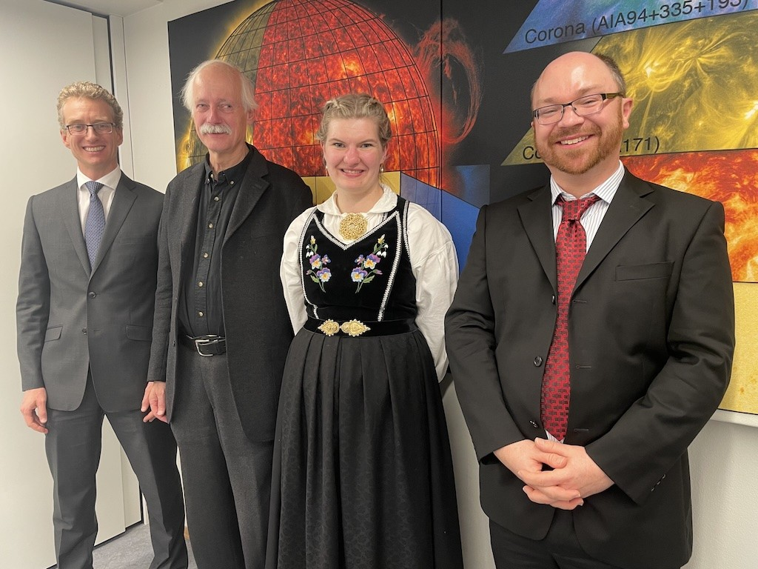
• Elisabeth Enerhaug who defended her PhD thesis ‘Identifying magneto-hydrodynamic wave modes in the solar atmosphere’ in Oslo on 17th October. Elisabeth had already defended her thesis in St Andrews in August; both were required for her co-tutelle PhD. The Norwegian defence included a trial lecture on coronal heating, a half-hour research talk and an hour’s public grilling from her two opponents, with an audience of friends, family and colleagues.
Elisabeth in traditional Norwegian dress, with her Oslo
supervisor Mats Carlsson, and the two opponents.

Former Staff
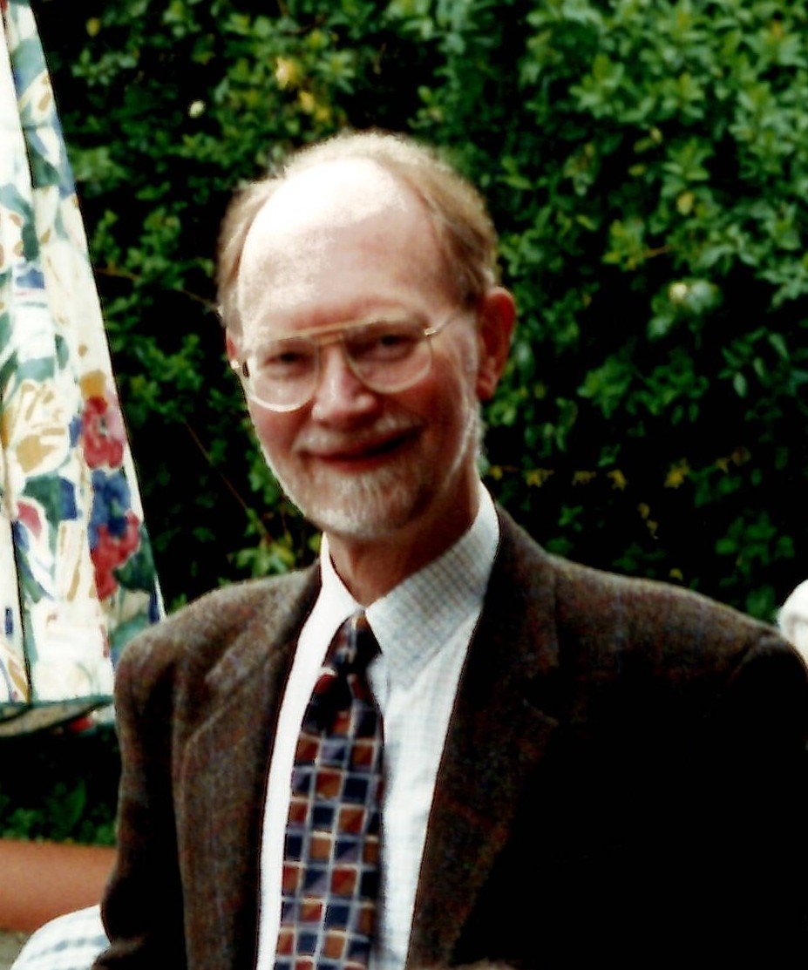
• David Kemp, Honorary Professor in Statistics for many years, died on 26th October. He was 98. On taking early retirement from the University of Bradford in 1983, David and his wife, Freda, moved to St Andrews, where they held honorary positions, and worked on discrete probability distributions. David’s other statistical interests included computational aspects. He was Secretary of the British Region of the International Biometric Society from 1961 to 1970. For many years David and Freda were joint Book Reviews Editors for Biometrics and they presented one of the first courses on LaTeX in the School.

Welcome to …

• Chen Lu who started as a research fellow in the NCAS (National Centre for Atmospheric Science) St Andrews climate and machine learning group at the start of November. She joins us from the International Centre for Theoretical Physics in Italy, where she specialised in the attribution of extreme weather events to climate change after taking her PhD at the University of Regina in Canada.

Conferences, Talks and Visits
• The School Inspiration Day was held on 22nd October, organised by Collin Bleak. There were presentations by Louis Theran, Nikos Sfakianakis, Collin, and Christian Ziar and Euan Donohue from the University Research Impact Team.
• The 5th Copson Lecture entitled ‘Loops, roots and complex truths’ was given by Professor Andrew Loob from Durham University on 11th November. Andrew spoke about how an amateur mathematician’s simple idea blending geometry, topology and algebra, led to a pearl of mathematics, the fundamental theorem of algebra. The Copson Lecture is named after Edward Copson who worked on complex analysis and was Regius Professor of Mathematics at St Andrews from 1950 until 1969.
• The JJ Valletta Memorial Lecture took place on 29th October, with Professor Karla Diaz Ordaz of UCL presenting ‘From causal inference to machine learning and back: a two-way street towards better science’. Karla mentioned a nice link with St Andrews in that our Rosemary Bailey encouraged her to branch out from pure mathematics and develop an interest in statistics, thereby shaping her future career trajectory. The seminar was very well attended as was the reception afterwards and the commemorative dinner at Mozza. The offer of free pizza for dinner and a chance to mix with the speaker and staff seemed to have a very positive effect on undergraduate attendance!
• Xiahui Li presented her PhD project at the 65th ISI (International Statistics Institute) World Statistics Congress in The Hague from 5-9th October. She also contributed to a panel discussion about epidemiological modelling.
• Peter Cameron and Rosemary Bailey visited the Institute of Mathematics of the Czech Academy of Sciences from 3rd-18th October. Peter was a research visitor, returning the visit to St Andrews by Wiesław Kubiś in April and May. He worked with Wiesław’s group on amalgamation properties for categories, and with another group on the extension problem for partial automorphisms of graphs. He gave a talk to the Set Theory and Analysis Seminar on 7th October on ‘Graphs (and simplicial complexes) defined on groups’, and Rosemary and Peter gave a joint talk (of over two hours) to the Seminar on Reckoning on 15th October on ‘Permutation groups, lattices and orthogonal block structures’.
• On 22nd October, Ben Swallow, Rosemary Bailey and Peter Cameron attended the Royal Statistical Society Discussion Paper meeting on ‘Balanced and robust randomized treatment assignments: The finite selection model for the health insurance experiment and beyond’ by Ambarish Chattopadhyay (Stanford) and Carl Morris and José Zubizarreta (Harvard). Rosemary provided a discussion contribution and Ben is Editor of the discussion paper series.
• On 27th October, Ben Swallow gave a seminar to the School of Mathematics Sciences at Durham University on ‘Some recent developments in Bayesian Gaussian processes for non-linear systems in computational biology’.
• Reinis Cirpons and James Mitchell visited Luna Elliott and Alex Levine at the University of Manchester from the 27th October-7th November, with Reinis doing a side-quest to Nantes for a day to start his new job there.
• Jon Fraser gave a seminar entitled ‘Dimensions of orbital sets in complex dynamics’ at the University of Manchester on his joint work with Yunlong Xu. Staying south of the border he also gave a colloquium at Loughborough University entitled ‘Dimension interpolation’.
• At the 8th Norway-Scotland Waves Symposium (Waves and Marine Hydrodynamics), held at the Royal Society of Edinburgh from 22nd-23rd October, David Dritschel presented a talk on ‘The Surface Quasi-Geostrophic Model’ and Josh Shelton gave a talk on ‘Subharmonic instability of gravity-capillary surface waves’.
• Daphné Lemasquerier visited Coventry from 3rd-6th November, where she presented two seminars on ‘Laboratory experiments of turbulent zonal jets.’ One was held at the Centre for Fluid and Complex Systems at Coventry University, and the other at the Engineering Department of the University of Warwick. The visit provided an excellent opportunity to explore their experimental facilities and foster connections with research groups working on fluid mechanics experiments using rotating tables.

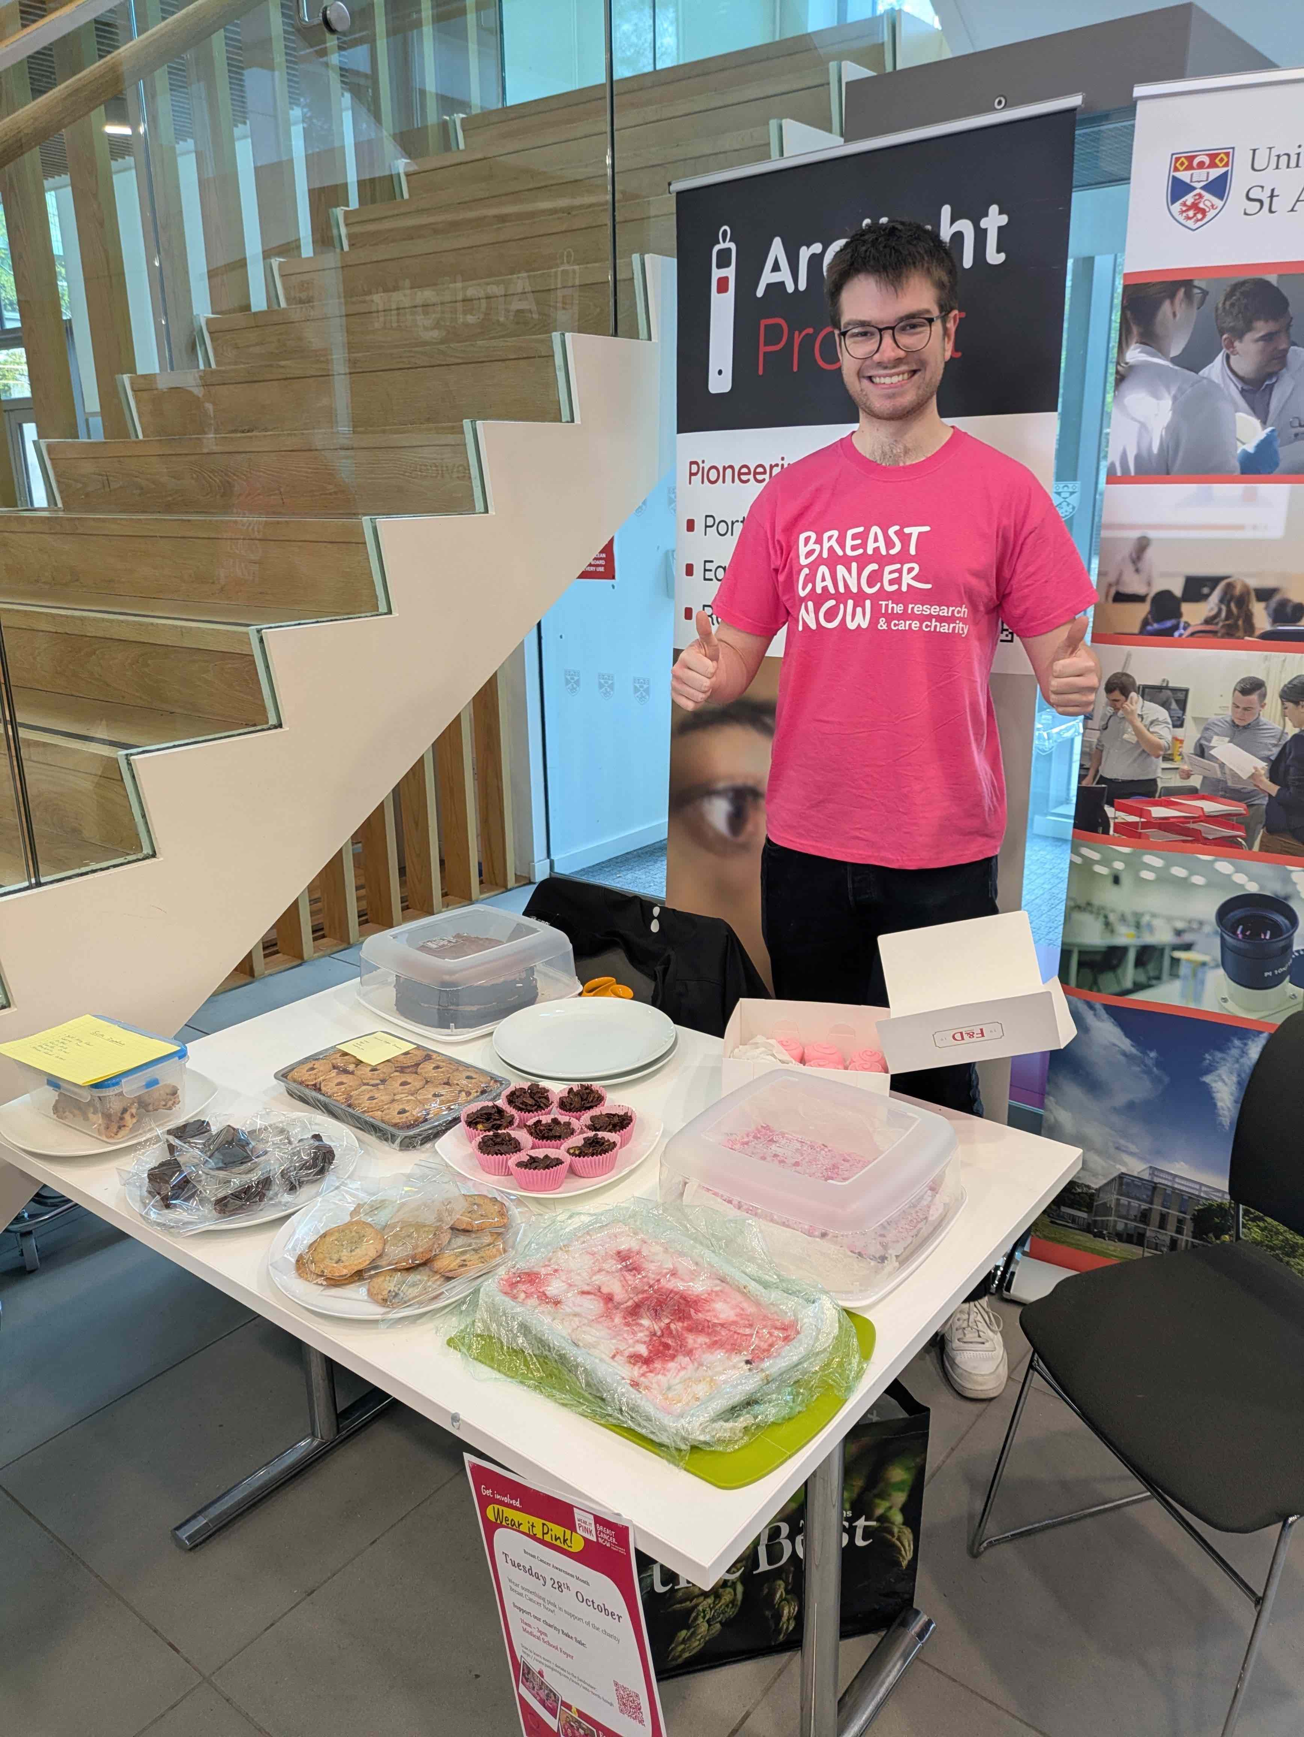
Other News
• On 28th October the school participated in a Wear it Pink day in support of the charity ‘Breast Cancer Now’. Including the money taken from the associated bake sale, we managed to raise over £400 on the day! This contributes to the £3,700 that we managed to raise over the course of the month from online donations. Thank you to everyone involved!
• The British Combinatorial Committee have named their PhD thesis prize the Bailey-Cameron Combinatorics (BCC) Prize, to honour our distinguished emeritus professors, Rosemary Bailey and Peter Cameron. The prize is open to anyone with a recent PhD from a UK university in the broad area of combinatorics, see this link.

Next Issue
• The next edition of the School Newsletter will be circulated in December. Items may be sent to maths-news@st-andrews.ac.uk at any time but a reminder will be sent out a week before the deadline.

